**7/11/2024**

Flex dashboard

Visualization scripting tools:

* Graphics:

Targets package: auto-running

* Every step in the script, I would need to pull out and each step is its own function and then it all gets put into the targets workflow.
  + Identifies where it breaks and then you can continue

Readme file could be where it updates from. – read me would be the document

<https://github.com/ryanpeek/drought_ca_monitoring>

if we wanted to use our custom raindrops:

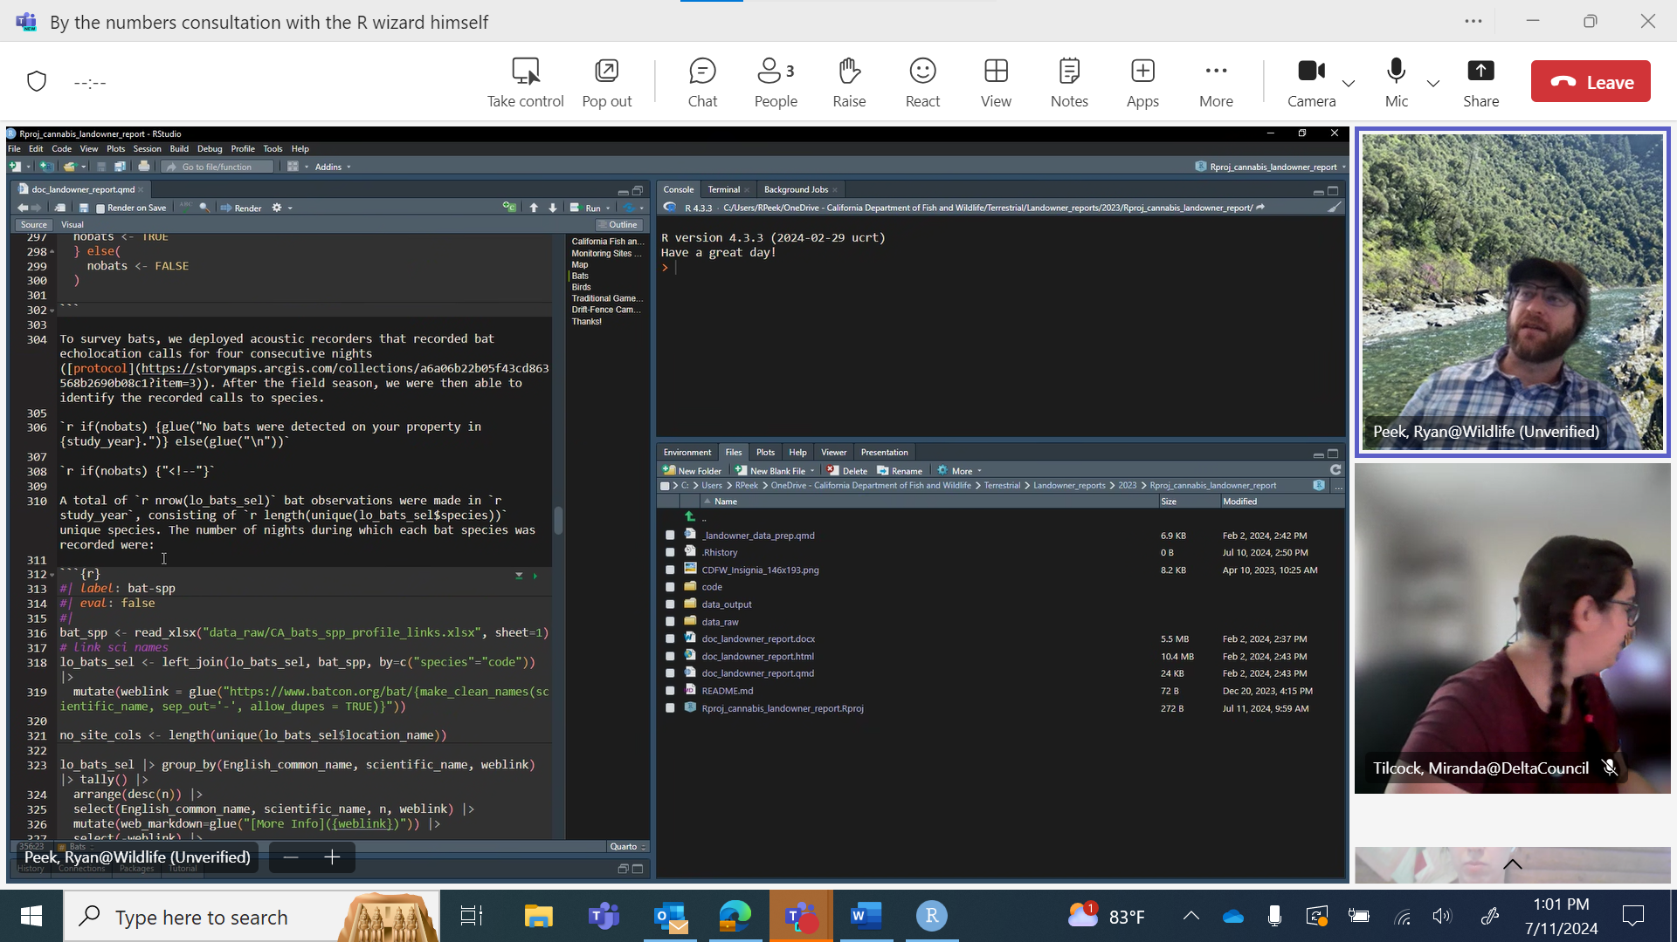

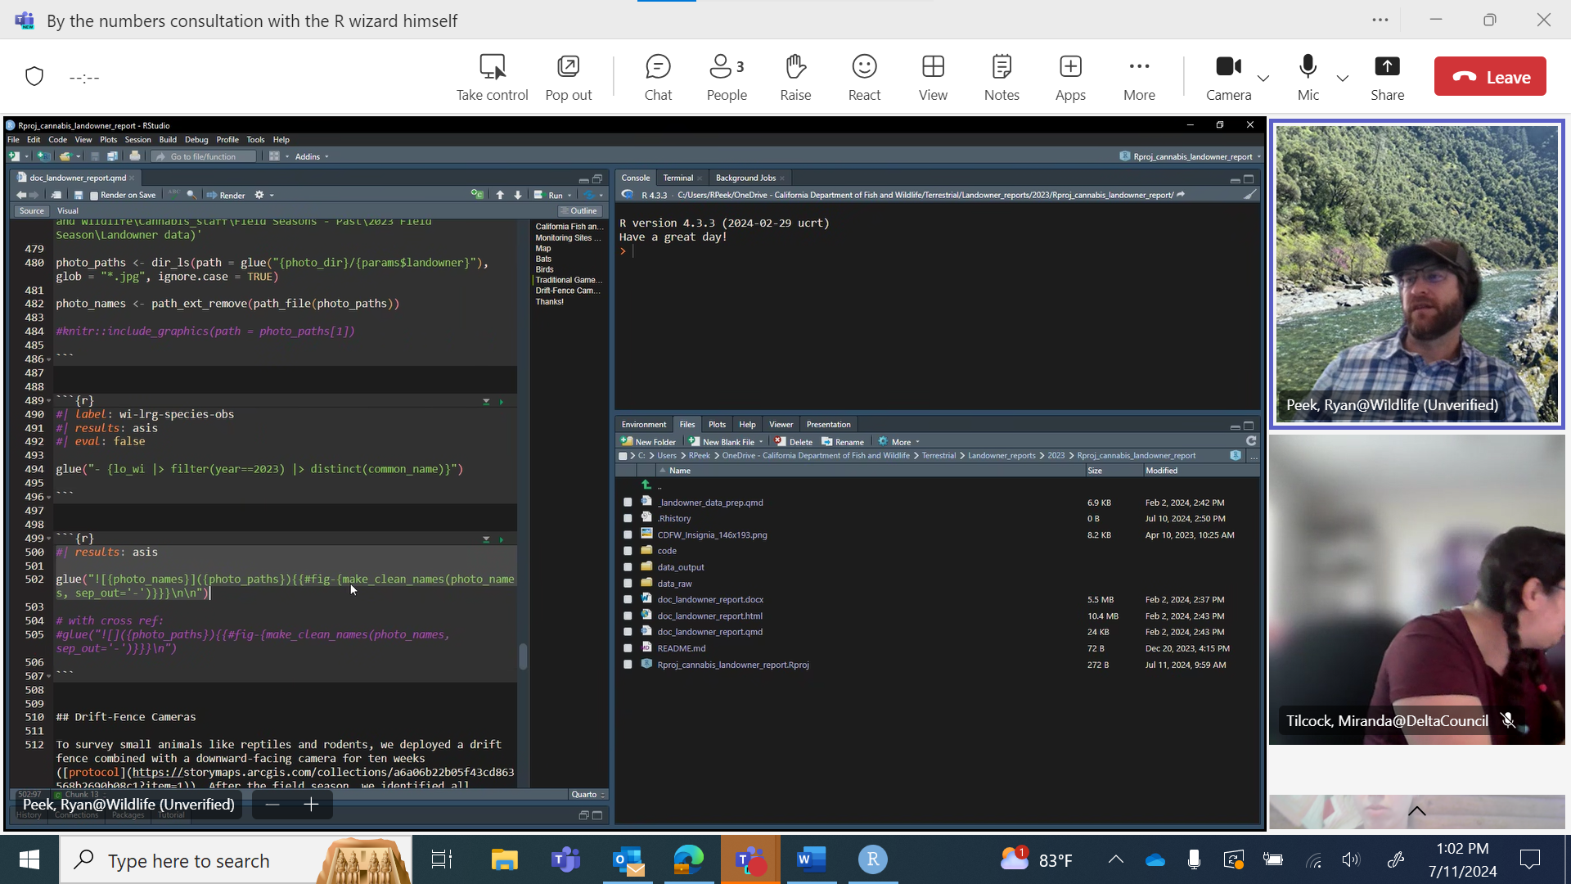

Start with one panel at a time for the info-graphic

* Then worry about putting them all together
* **Get data, clean it up**
  + **For the reservoir , make an individual plot for each reserviour level**
  + Reservoirs

Flex dashboard: Rmarkdown only – going /on their way out

Quarto: can make interactive plots: dashboards.

Take string of character that includes numbers and just pull the numbers out.

**7/3/2024**

Add code to the project

Base map for each section – using sf package [NCEAS Open Science Synthesis for the Delta Science Program - 10  Using sf for Spatia Data & Intro to Making Maps (ucsb.edu)](https://learning.nceas.ucsb.edu/2023-08-delta/session_10.html)

* Temp gages
* Reserviours
* Flow gages
* Conductivity

Data visualizations: plot of where we are currently at versus where the historical average is. – cdec

* Water exports,
* Salninty
* And temperature
  + Have an explanation of the plot.
    - How does that get updated every month?
      * Need to have bounds so it only shows one month at a time
      * “these numbers are low this could indicate xyz”
* Need it publicly accessible – so that it doesn’t live on my computer.
* Add new information to xlsx
* Flex dashboard
* Meeting with ryan to get it off my computer so it
* Make visuals besides plots. 🡪 like ppt we submit monthly

**6/24/2024**

Present to council bt#’s history:

* Walk through the different panels
  + We report on ppt
  + Temp: map why they are important
    - Variation in the year. Show Jan versus Aug
  + Why the locations are important
    - Why we expect salinity to be higher or lower in a certain area – above x number in this location. Its really important this area stays more fresh.
  + ‘health’ indicators of our delta.
    - Relate to fish
  + Why we present on each type of metric
  + What do the units mean
  + Setting context for locations and what the values mean
* Power point template:
  + [Delta Council Insite - PowerPoint - All Documents (sharepoint.com)](https://deltacouncil.sharepoint.com/sites/DSCInsite/Shared%20Documents/Forms/AllItems.aspx?csf=1&web=1&e=028T10&ovuser=d148bc0e%2D677b%2D46d1%2D9d69%2Df9e6a16fda9a%2CJessica%2EWeidenfeld%40deltacouncil%2Eca%2Egov&OR=Teams%2DHL&CT=1719253274946&clickparams=eyJBcHBOYW1lIjoiVGVhbXMtRGVza3RvcCIsIkFwcFZlcnNpb24iOiIyNy8yNDA1MDUwMTYwMSIsIkhhc0ZlZGVyYXRlZFVzZXIiOmZhbHNlfQ%3D%3D&CID=85da35a1%2Db026%2D5000%2D864c%2D3508654630f4&cidOR=SPO&FolderCTID=0x012000E91826C899609C47B3ACC88F41CF3F6B&id=%2Fsites%2FDSCInsite%2FShared%20Documents%2FAgency%2DWide%20Docs%2FCommunications%2FTemplates%2FPowerPoint&viewid=1862aa59%2Da911%2D4062%2Da73a%2Da436d30ec2c0)

BT#’s brain storm with Miranda 6/24/2024

* Make sure this isn’t stuck on my computer.
* That it isn’t stuck on my computer
* Quarto that isn’t linked to my github
  + How can I have access to Delta Council GitHub- Miranda is making a repository and linking me to it
* Put all BT#’s code into GitHub

-------

by the numbers meeting

- BT#

-idea: add ground water status

By the numbers master 2024

use the powerpoint from the previous month since numbers will be fairly similiar and you can follow whats going on

- Date of the council meeting is waht goes up top.

Delta stewardship council meeting

and then put the day that we calcuated the numbers.

water year starts oct 1st and ends sept 30th

how long do we do snow pack until? - they are unsure. We start talking about water temp instead.

--> present station differently for water temp. unknown location/ not well known locations

Precpipiation: 'current',

- these are both cummulative

central sierra. use current.

Snow pack

- norhtern and central and statewide

color means, good, bad average. --> numbers bottom right of ppt doc.

reserviour storage

- percent of average storge, not percent of capacity.

--> need adjustment capability. (can ask to create a new info graphic) capacity versus average is not accurate.

Water FLow and Quality:

- could be full of erros

- right click anywhere on table to refresh

- take average for the month we are in

exports: its a pdf "total delta exports" daily total and average for the month at the bottom of that chart.

--> need to go back and update the complete full month for CFS

for the cm & ppm

- we just present of what it is. Average? Below?

why is this important - what does this mean --> maybe a presentation.

We have three different stations

ppm --> need to find temp gages at the salinity stations

--> in by the numbers "BTN readout"

- screen reader/ its for accessability

change the 20-year flow--> see how many years it actually is.

agenda item * put as X and highlight

once finished --> look back over everythign - quick double check numbers look good.

read the word document

Performance measurems of the delta science plan

shiny or tableu

- connect by the numbers

shiny needs to be regularly maintainted

make a dashboard and room for information --> can provide context

--> what does it mean when something in the green, something in the red.

- can make a blog about it. - if there will be more of a public interface.

Gets sent to Emma (Maggie gonna cc me)

Usually due the Tuesday before the end of the month. numbers are relatily fresh for the council meeting.

-----

try to automate what we can in R first

then from tehre using a dashboard website:

- shiny would need an SOP/Read me

quarto - very similar to Rmarkdown

--> need to make sure it is publicly accessable

seasonal presentation to the council - lisa marie present generally but then we can do a seasonal one- these are the condidiotns we expect and winter crazy rain, floods ect.

snow melt we will expect to see these changes. temp will stay cooler.

why is this part of the lead scientist report. - seasonal one. 5-10 min presentation.

SOP's for all of this.

-for the code

- for the presentation

lack of SOPs

set up git hub

set up R project

start with Rmarkdown

try to Rvest to pull numbers

--> if doesnt work, find data that feeds into that. to see if i can pull from it.

build a map in R --> where the readings are coming from.

by the numbers report -- how to automate it.

https://explore.baydeltalive.com/

another idea for an indicator -->

https://explore.baydeltalive.com/ --> maybe soemthing from here

by the numbers need context besides red, blue, green. - part of the lead scientist report

dashboard due: for LSR

- may 23rd council meeting due complete May 7th. - email that maggie sent to all program managers. ~ 2 weeks before the council meeting the LSR is due.

- want papers that are related to whats happening to the coucnil. Funded by the council, or related to what is going on.

- Summary - make less technical. Febuary/march one: paper that lisa marie wanted us to. Drought synthesis work.

focus on the abstract and then the methods before and the final conclusion.

--> pull out some key things that were intresting.

--> how they did it. what questions they were specifically asking in this paper. and i can find the answers in the conclusions.

this is what thye found. Correlations.